Kol Simcha Torah Gazette
For parshas noach 5785
Volume 9 Issue 6 (Whole #420) 1 Cheshvan 5785/ November 2, 2024
Printed L’illuy nishmas Nechama bas R’ Noach, a”h

For a free subscription, please forward your request to keren18@juno.com
Past emails can be found on the website ShabbosStories.com under Brooklyn Torah Gazette

How One Man and His Family
Survived the October 7th Massacre
By Sarah Pachter

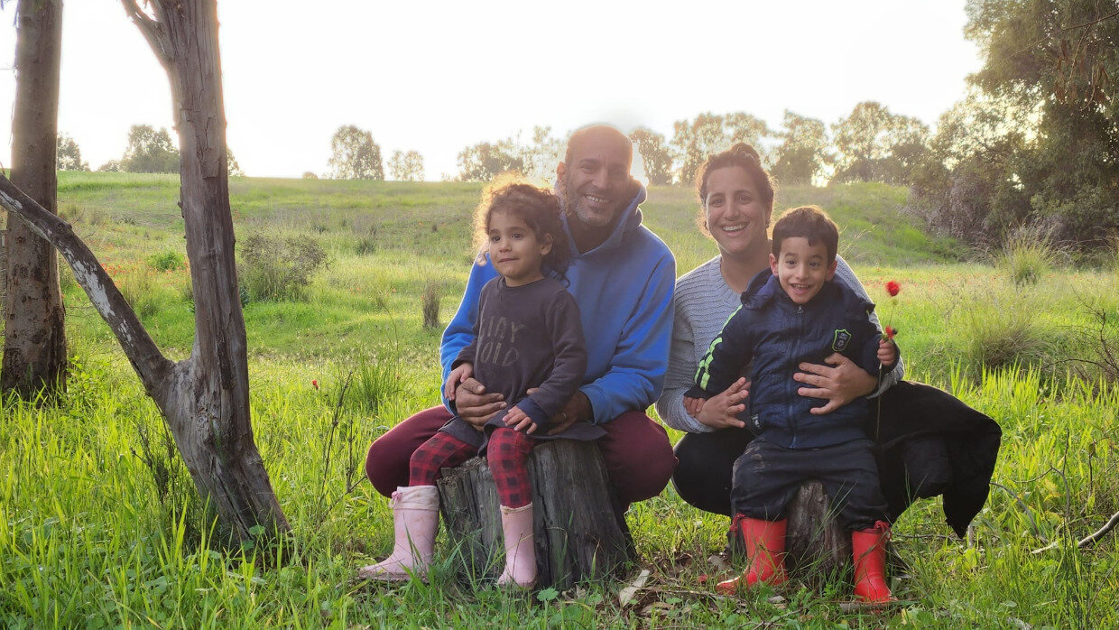

Itay Shabi is certain that he experienced a few miracles that fateful day.
It was 6:30 AM on October 7th when Itay Shabi and his wife, Moran, woke up to the sounds of pervasive rockets and bullets tearing through the sky. Everyone living in Kibbutz Beeri had been jolted from their sleep.
“From the beginning, we sensed that a war had started because it was unusual, even for us. The bullets and rockets did not stop all day long, until we escaped. There was a battlefield of bullets outside. The terrorists were screaming in Arabic outside.”
Pre-October 7th, the residents of Kibbutz Beeri lived “harmoniously” next to the border of Gaza. The Jews in the Kibbutz extended tremendous kindness regularly to the Gazan civilians. Many of the members of the Kibbutz would drive to Gaza to transport sick children who needed surgery to Israeli hospitals, wait with them during and after their procedure, and then bring these children back to Gaza.

Running for Shelter
When the rockets began to fly overhead, the first thing Itay and his family did was run to the bomb shelter. Initially, they didn’t close the door because they assumed the rockets would last a few seconds and then they would be able to escape by car if needed. But the rockets continued to fall and they then realized that this was going to be a long ordeal. They closed the door.
“Within a few seconds of closing the door, we started getting text messages that there are terrorists inside of Kibbutz Beeri. People sent pictures to accompany the text messages. We understood what was happening as we started to hear shooting.”
Around 7:00 AM, Itay and his family began to hear screaming in Arabic.
“At 7:10 AM, the terrorists knocked on the door to our house. Just knocking. No banging.” Itay was bewildered. “I was thinking, a simple knock? I do not know why they just knocked. Maybe they were trying to fool us into thinking they were not terrorists.” Thankfully, they did not open the door.

The Text Messages Became More Intense
The text messages became more intense. They knew where the terrorists were and could follow their path based on the flow of incoming texts.
After three hours, at 10:30 AM, the terrorists broke into the house.
“We understood that the terrorists were getting closer and closer and closer. I have one boy and one girl who are four years old. We were sitting in the bomb shelter with our twins, Sinai and Benaya.”
The four of them just waited. The army was unable to help because every time soldiers arrived on the scene, they were outnumbered by barbarian terrorists and killed.
“The minute they broke inside the house, the dog started barking. They shot and she started to whimper, so they shot again and again and again. They kept shooting. One of them shouted in Arabic: ‘Khallas Khallas… Which means stop. They did not want to waste more ammunition on the dog. Then it was silent.”
Itay placed his hand tightly onto the door handle of the bomb shelter while silently praying the Shema. This agonizing terror went on for 30 minutes.
They struggled with me. They kept trying to pull the handle down, and with my strength and the help of G-d, I kept pushing the handle up.
“We heard the terrorists breaking everything inside, windows, glass… Then they started to try to open the door. They struggled with me. They kept trying to pull the handle down, and with my strength and the help of G-d, I kept pushing the handle up.”
Moran was sitting on the bed with the two children holding her tightly. Then the electricity went out.
After a few minutes of tugging on the door handle, the terrorists gave up. They took tires, set them aflame, and threw them into the vent of the bomb shelter. “I took out my telephone and used the light to see what was going on. I realized then that smoke was entering the bomb shelter. Almost immediately, the dark smoke began to fill the room.”

Trapped
“I told my wife that we have to surrender. I told her we must put our hands up, and we had no choice but to open the door. I went to open the door but could not get it open. They had broken the handle on the other side in order to trap us.”
When Itay and his family were unable to surrender through the door, there was only one other way out. Through the window.
“I was so scared. I just knew that the moment I opened the window, I was going to get a bullet to my head. I knew it was the end, but we had no choice. We could not breathe anymore. This was the only option.”
Miraculously, the moment Itay opened the window, there was no one in sight. He jumped out first and then Moran handed him the two children.

Long Hours that Felt Like an Eternity
“She gave me the kids, and I put them down underneath the small palm tree that we have in our garden. I just put them there because it was the closest place next to me. My wife came out, we closed the window, and sat under the palm tree and the branches. We each had a child on our lap.” The tree was slightly bare, but Itay pulled whatever branches were left towards him and they sat there for five, excruciatingly long hours which felt like an eternity.
Within minutes of their escape from their house, Itay’s property was filled with Hamas terrorists and Gazan civilians alike. “We watched the Gazans go inside our home and take everything. These were the same civilians our neighbors had driven to and from the hospital in order to provide surgeries for their children.” They watched this in silence, as they could not move or breathe audibly lest they be discovered.
“The terrorists stood 30 centimeters from my body. His leg was right next to me. I have no clue how they passed by several times and didn’t see us. This is surely a miracle from G-d. Nothing else.”
Itay kept praying, “Give me the strength, G-d, just a little more. Don’t leave me alone, don’t leave me alone.”
At one point, Moran signaled to Itay that they should run towards a bamboo grove since those trees were taller. Itay reasoned, “Listen, there are dozens of terrorists in front of us and for some reason they don’t see us. Something is hiding us, and we can’t move.” He later reflected, “Miracles are hard to grasp—I still do not fully grasp it, and I was the one who experienced it. The terrorists did not just pass once…they passed by us numerous times.”
They carried on like this for several more hours. Eventually, the family stopped hearing screaming in Arabic and only heard distant gunfire. They understood from this that the terrorists had moved further away.

Realized That They Had to
Their Hiding Spot
The surrounding smoke was building up, and Itay realized that they had to finally leave their hiding spot.
“We held the children, and checked that the area was free and clear. We started to run, and noticed there were terrorists on the roof, shooting at people. Moran took a left turn and then froze out of fear. I started to yell at her to keep moving, and the terrorists must have heard me because they started to shoot at us. We both ran and heard the bullets getting closer and closer. I could hear it in my ears, and I understood we were being chased.”
Itay found some branches on the ground and started to gather them together to make a mound. They dove underneath the pile and hid silently for another five hours, until nightfall.
Up until that point, the family had not eaten a thing, did not have anything to drink, nor had they relieved themselves during the entire ordeal. Their young, 4-year-old twins cooperated every step up the way and did not make a sound or voice any complaint.
“I didn’t tell the children anything. They cooperated because they understood the situation. They saw the fear in our eyes. They went 14 hours without drinking or eating and in complete silence all 14 hours. My kids typically have a lot of energy, especially my daughter. This was another miracle.”

The “Jeep” that G-d Sent
The biggest miracle of all took place when darkness fell and Itay got up to relieve himself.
“I was standing up in front of a tree and looked towards the side. I saw the red lights of a Jeep. I thought it was a Hamas Jeep. All these thoughts were racing through my mind, and I just knew I was going to die. When the Jeep shone its lights on me, I knew we had been caught.
“I started to hear voices, but as they came closer, I heard Hebrew. It was Israeli soldiers. I shouted, ‘Soldier!’”
“Who is this?” they demanded.
“I told him, ‘I am a father with my kids. Please help us!’” They were in safe hands now. Finally.
The soldiers proceeded to drive them back towards their Kibbutz. They saw multitudes of dead bodies of their friends and of terrorists.
Itay and his family also drove by Moran's parents’ home and they tragically saw that it was burnt. When Moran's parents did not pick up the phone they understood the agonizing reality of their death. It was confirmed ten days later.
“The soldiers even took us through where the Nova party took place, and we saw the road filled with bodies. There were hundreds of kids lying all over, burnt. No one can forget what they did to us that day.”

Soldiers Were on a Secret Mission
Months later, the soldier that rescued Itay asked him, “In the end, how did you find us? We were on a secret mission, trying to be undetectable.”
Itay responded that it was the red lights from the Jeep.
“What Jeep?” he asked. “We arrived by helicopter and were completely clandestine.”
There was no Jeep. There were no lights. But Itay is still positive that he saw them.
“The power of the army is that they do everything hidden. You can tell me it’s mazal, mazal, mazal, but I’m telling you I saw red lights with my eyes. It was a revelation, more than just mazal. I saw something physical… I am certain it’s a miracle.”
Perhaps one of the most fascinating parts of the story is that this was the first Sukkot that Itay had ever built a sukkah.
“I wanted to build it with my bare hands. I did not want to buy a premade one.
I wanted my children to see me building it, and ask me questions about Sukkot so that I could teach them.”
Itay had gathered planks of wood throughout the Kibbutz and built it himself. He then found a large palm tree in the entrance of the Kibbutz and cut branches for the roof.
There were a lot of gaps in the roof that needed covering. That’s when Itay noticed that he had a dwarfed palm tree in his courtyard. “I had never noticed it before. I cut the branches from it as well in order to fill in the gaps. That tree is the same tree that we hid behind. It was supposed to be more-full, but because I cut branches from it for the sukkah, it was very sparse and bare. We did not have a choice and hid there anyway, but it still saved us.”
Itay is still processing the experience and doesn’t understand why he was spared while others weren’t. He wonders if the merit of making a sukkah enabled him to successfully hide amid the remaining branches of the palm tree.
“Not one souvenir is left of the house. The roof is also burnt, but the sukkah? Nothing happened to it. The flame stopped right at the connection between the house and the sukkah. I had never in my life built a sukkah before. I still do not fully understand it. I came in contact with death, but G-d had another plan for me, maybe some sort of purpose.
“It is impossible for me to say there is no G-d after what I saw. After I was saved ten times from death? It was only G-d. I want the world to understand that we have G-d, but we need to unite. We have two legs, a right leg and a left leg. If we do not all walk together, we will fall. G-d is here and helping us, but for Him to help us, we have to help each other. We have to understand that people can think differently and still get along together.”

Reprinted from the current website of aish.com A version of this article originally appeared in Ami Magazine.
******************************************************************
“And, as for you, take for yourself of every food that is eaten and gather it in to yourself, that it shall be as food for you and for them.” (6:21)

The Gemara states, as if quoting Hashem, “The entire world is sustained in the merit of My son, Chaninah [one of the sages of the Mishnah].” This means, explains R’ Elazar Shapira z”l (1808-1865; Rebbe of Lancut; son of the author of Bnei Yissaschar), that the tzaddik of the generation is the conduit through which blessing and sustenance flow to the entire world. Ironically, that tzaddik does not need to work hard to support himself. Even if he performs only a token act of hishtadlut / physical effort, he finds his sustenance. R’ Shapira continues: This lesson is learned from our verse. How so? Because Hashem told Noach to take food for all of the creatures that would be on the Ark, but Hashem never told Noach how long their stay on the Ark would be. It seems that it did not matter. As long as Noach performed some modest hishtadlut, the sustenance of all the creatures on the Ark would be guaranteed in his merit. (Yod’ai Binah)

Reprinted from the Parashat Noah 5785 email of R’ Yedidye Hirtenfeld’s whY I Matter parsha sheet for the Young Israel of Midwood in Brooklyn.

Not Devastation and Punishment, But Rather Purification
and Spiritual Elevation
From the Teachings of the Lubavitcher Rebbe
Rabbi Menachem Mendel Schneerson, Zt”l


It sometimes happens that the external appearance of a thing or event can be in stark contradiction to its true meaning. For example, if one happens to see a parent in the midst of disciplining his child, his actions might seem to be an expression of cruelty. In truth, however, the parent is motivated by love and concern for the child's welfare.
On a larger scale, an event or occurrence can take place in the world that seems to be negative, yet ultimately derives from a positive source and is actually beneficial. A prime example of this was the Great Flood in the times of Noah, as described in this week's Torah portion. Outwardly, it was a terrible phenomenon - the annihilation of every living thing on earth. But on a deeper level the Flood signified spiritual purification and cleansing, similar to immersion in a mikva (ritual bath).
The Midrash relates that during the Flood the world was in a very exalted state, much like the very beginning of creation. Completely submerged in water, the entire world was an expression of "praise of the Holy One, Blessed be He."
What does being underwater have to do with praising G-d? Moreover, how does this relate to the simple, literal significance of the Flood, which was death and destruction?
To explain:
The most salient property of water is that it covers whatever is submerged within it. When an area is flooded, its numerous disparate features disappear, and it acquires a uniform appearance. Nothing protrudes from the surface; no element declares that it is different from any other. In this sense, water is symbolic of the underlying G-dly unity of existence.
This is also the deeper significance of immersion in a mikva: the individual's nullification of his essential self before G-d. This was the initial state of the world immediately following creation and also during the Flood, when the whole world was nullified and subsumed in the greater G-dly reality.
On the physical plane, the Flood manifested itself as devastation and punishment. But the inner, G-dly intention was the world's purification and spiritual elevation.
Nonetheless, G-d promised that He would never again bring a flood upon the world, as according to Divine plan, this nullification must occur as a result of man's service rather than come from Above. The underlying unity of existence will be fully revealed in the Messianic era, when "the world will be filled with G-dly knowledge as the waters cover the sea."

Reprinted from the Parshat Noach 5762/2001 edition of L’Chaim. Adapted from Volume 30 of Likutei Sichot.
Noach was a righteous man, perfect in his generations. (6:9)

The Gemara in Megilla says that Yaakov said to Rachel when they met Marry me. Rachel answered “yes, but my father is crooked and will do something to prevent the marriage.”
Yaakov responded “don’t worry , I am his brother in trickery and I will not be tricked.”
Rachel answered “but how is it permitted for a Tzadik to act in such a way?” Yaakov responded “with a thief one is permitted to act with thievery.”
The question becomes if the entire generation were thieves, why was Noach required to act as a righteous person? With thieves one can act as a thief. The Chasam Sofer says that the Heter to trick a thief is only a ‘one time’ Heter. It does not give a person permission to always act as a thief just because the entire community is made up of thieves. Because if a person always acts as a thief, he will become a thief and be no different than everyone else .Therefore Noach - although he lived among an entire generation of crooks, was not permitted to act like them. (Toras Moshe)
Reprinted from the Parashat Noah 5785 email of R’ Yedidye Hirtenfeld’s whY I Matter parsha sheet for the Young Israel of Midwood in Brooklyn.
Rav Avigdor Miller on
Beards, Authority and Equality

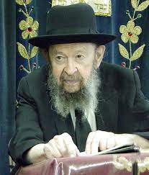
QUESTION: What was Hashem’s purpose when He caused men to grow beards?
ANSWER: We have to study that. A beard you must know is a sign of authority. It makes the chin bigger. If you have a big chin, you’re more assertive, you’re more important. And so the purpose of the beard is to emphasize the size of the face and to elongate the chin; and it means that men must be the leaders.

Women Must Only Be Second
Mates and Not Captains
Now, it’s only here that I can say that. Outside, you would be an apikores; but we have to understand that the truth of the world is that men must always take the lead. Women must be only second mates and not captains. And no matter what you read in the newspapers, no matter what kind of laws are passed or what verdicts silly judges will give, there’s no such thing as equality between men and women. It’s a false dream. There never was such a thing until America; and like all crazy things that are happening in America this stupidity is also taking place today.
Women should not be judges. Women become radicals. They fly off the handle. Men are more deliberate in judgment. The career of a woman when she is most successful is when she is in her family and she is raising children. That’s her happiness and success.

Political Office is a Disaster Not Only
for the Woman, But for the Community
A woman who goes to Congress or a woman who is a councilwoman is a total failure. It’s a disaster. Not only is it a disaster for the community, it’s a disaster for her. She didn’t get married. She didn’t have children. The whole glory of a woman is the family that she produced. Forever and ever those children will produce merit, zechuyos, that go to the father and the mother.
How fortunate is a mother who has sons and daughters that will walk in the way of Hashem. That’s the career, that’s the profession for which a woman was created. And therefore, women don’t have beards. It’s important to realize that women are marked and men are marked.
Now of course there are certain other purposes. Of course, if women had beards, nobody would marry them. There’s no question a woman with a mustache would wait a long time before anybody proposed to her. And so that’s one of the reasons why a woman doesn’t have a beard but it’s certainly true that the purpose of the Borei Yisborach is to give the authority to man.

You Cannot Deny the Testimony of
Nature, History and the Torah Itself
There’s no question about that and no matter what the modern orthodox will tell you, you cannot deny the testimony of nature, the testimony of history, and the testimony of the Torah itself.
So now you know why it’s worthwhile for a man to grow a beard – to let him know that he’s a man. Otherwise, you might think he’s an old woman.
That’s his heritage. That’s his right. It’s his right in the family. He sits at the head of the table. The beard recognizes that he’s the leader of the family. And therefore, when people live according to nature, they’re living according to Torah. But when they remove the beard so they’re lacking the symbolism of nature and naturally they’re lacking the symbolism of the Torah.

Reprinted from the archives of Toras Avigdor (Tape #729, March 1989).

Thoughts that Count
for Parshat Noach

And Noah walked with G-d (Gen. 6:9)
Noah himself was a G-d-fearing man, but he did not reprove other people or encourage them to improve their behavior. For that reason, he is termed "perfect in his generation": He was not disliked by his fellow man, as no one really cared how he conducted his personal life - provided he did not make any unpleasant demands on them. (Ketav Sofer)

And the earth was corrupted before G-d (Gen. 6:11)
Only in G-d's eyes was the earth "corrupted," whereas mankind considered the world to be pleasant and good. The members of Noah's generation were perfectly satisfied with the rules they had established to govern their society. (Rabbi Avraham Saba)

Of clean beasts, and of beasts that are not clean (Gen. 7:8)
According to the Talmud, the Torah uses an extra eight letters to describe the non-kosher animals in this manner, rather than portray them negatively as "unclean" or treif. Elsewhere in the Torah, however, such as those verses enumerating which animals we are allowed or forbidden to eat, they are clearly defined as "unclean." The difference is that when it comes to a matter of Jewish law, fancy language is inappropriate. The law must be stated definitively and unequivocally: "This you may do, and this you may not do." (Rishonim)

And they went to Noah into the ark...of all flesh where there is the breath of life (Gen. 7:15)
The G-dly revelation that was manifested in the ark had a profound effect on all the animals, causing them to live together amicably and harmoniously for an entire year. Thus, the conditions in the ark were the prototype and forerunner of the Messianic era, when according to many commentators, the Biblical prophecy of "and the wolf shall live with the lamb" will be fulfilled in the literal sense. (Hitva'aduyot 5743)

Reprinted from the Parshat Noach 5762/2001 edition of L’Chaim.

13 Facts You Should
Know About Terah
By Rabbi Yehuda Altein

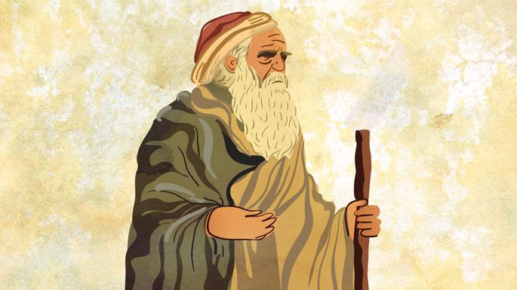
Art by Sefira Lightstone

Terah (also spelled Terach) was the father of Abraham, the first Patriarch of the Jewish nation. Although Terah was a prodigious idolator, his son Abraham recognized the truth of one G-d. Read on for 13 facts about this unsavory ancestor of ours and his end-of-life turnaround as unpacked in Midrashic sources.

1. He Was Ninth in Line from Noah
Terah’s genealogy is clearly outlined. The Torah lists 10 generations from Adam until Noah,¹ and another 10 from Noah until Abraham.² Terah, Abraham’s father, was the ninth generation from Noah and the nineteenth from Adam.
2. He Had Three (or Four) Sons
When Terah was 70 years old, his wife gave birth to Abraham (then known as Abram). He also had two more sons—Nahor and Haran.³ Interestingly, some say that Terah remarried later in life and had a fourth son named Tzova.⁴

3. His Wife’s Name Was Amathlai
The Torah doesn’t mention Abraham’s mother by name, but Jewish tradition fills in the blanks. According to the Talmud, her name was Amathlai, the daughter of Karnebo.⁵ Terah had at least one additional wife, as Haran’s mother was a different woman.⁶
4. He Was Nimrod’s General
Midrashic sources tell us that Terah wasn’t just an average citizen. He was a military general under Nimrod, the powerful ruler of ancient lower Mesopotamia who professed to be a god.⁷ But even Terah’s high rank did not grant his family immunity, as seen in the dramatic events to come.

5. He Saved Baby Abraham’s Life
Tradition relates that when Terah’s son Abraham was born, Nimrod’s astrologers warned that this child would one day conquer the land. Fearful of Nimrod’s wrath, Terah hid Abraham, his mother, and a wet nurse in a cave, saving his son from certain death. Abraham remained hidden in the cave for 10 years.⁸

6. He Ran an Idol Shop
Terah was deeply involved in idol worship, even running a shop that sold idols. One day, when he left the shop in Abraham’s care, his son famously smashed the idols, declaring that the statues had no real power. Enraged, Terah reported Abraham to Nimrod, who had him thrown into a fiery furnace—only to witness Abraham survive the flames unharmed!⁹

7. Haran Wasn’t as Lucky
Though Abraham was saved, Terah’s other son Haran wasn’t as fortunate. Torn between loyalty to his father’s deities and his brother’s faith, Haran chose Abraham’s side only after seeing his miraculous rescue. Sadly, Haran himself was then thrown into the furnace, where he perished.¹⁰

8. He Read the Stars
Terah was known to practice astrology. He saw in the stars that his son Haran would die by fire but that Haran’s descendants would fill the land. Indeed, Haran’s daughter Yiskah, identified as Sarah, went on to become the matriarch of the Jewish people.¹¹

9. He Wanted to Make Aliyah … Sort of
The furnace incident¹² prompted Terah to move from his hometown of Ur Kasdim to the Land of Israel, then known as the Land of Canaan. He was joined by Abraham, his wife Sarah (then called Sarai), and Lot (Haran’s son). They stopped midway, however, settling in the city of Charan.¹³ Abram would later continue to Canaan at G-d’s command, where G-d bequeathed the land to him and his descendants for eternity.¹⁴

10. Some Say He Made the First Currency
One intriguing tradition credits Terah with being the first person in history to fashion currency.¹⁵ This shows that he had an important role in the development of civilization, beyond his family drama.

11. We Talk About Him at the Passover Seder
At the Passover seder, we express gratitude to G-d by contrasting our idolatrous past with our divine destination.¹⁶ In this vein, we repeat the verse from Joshua: “So said the G-d of Israel: ‘Your ancestors dwelled across the river, Terah the father of Abraham and Nahor, and they served other gods. I then took Abraham and brought him to the Land of Canaan, where I increased his progeny …’”¹⁷
12. He Repented in His Later Years
Despite decades of idol worship, Terah eventually saw the truth of the belief in one G-d. Some traditions say he repented on his deathbed,¹⁸ while others believe he changed his ways much earlier,¹⁹ influenced by his son Abraham.²⁰ Either way, Terah’s story ends on a positive note.

13. He Is a Lesson in Contrasts
That the progenitor of the Jewish nation was born to an idolatrous father is striking indeed.²¹ This goes to show the power of the Jewish soul, which can defy nature and nurture and shine its true colors.

Footnotes
1. Genesis 5:3–29.
2. Genesis 11:10–26. See Ethics of the Fathers 5:2.
3. Genesis 11:26. See the discussion in Talmud, Sanhedrin 69b as to whether or not Abraham was the oldest of the brothers.
4. Sefer Hayashar, cited in Seder Hadorot, year 2075.
5. Talmud, Bava Batra 91a.
6. Rashi to Genesis 20:12.
7. Sefer Hayashar, cited in Seder Hadorot, year 1657.
8. Sefer Hayashar, cited in Seder Hadorot, year 1948. See also Pirkei D’Rebbi Eliezer, ch. 26.
9. Bereishit Rabbah 38:13.
10. Bereishit Rabbah 38:13, cited in Rashi to Genesis 11:28.
11. Yalkut Shimoni, remez 77.
12. See Nachmanides to Genesis 11:28 that Terah left Ur Kasdim out of fear of Nimrod. See Chizkuni, Seforno, and Ohr Hachaim to Genesis ad loc. for other reasons behind the journey.
13. Genesis 11:31.
14. Genesis 12:1–7.
15. Seder Hadorot, year 1878, citing Shalshelet Hakabbalah and Tzemach David.
16. See Talmud, Pesachim 116a.
17. Joshua 24:2–3.
18. Nachmanides to Genesis 11:32.
19. Rashi to Genesis 15:15. See Likkutei Sichot, vol. 5, p. 307.
20. See Radak to Genesis 11:32.
21. See Bamidbar Rabbah 19:1.

Reprinted from the current website of Chabad.Org

